  - Banco Federal de Finanças
  - Marketing Campain Analysis

Presented By

Ahlstrom, Sydney
Gain, Jacob
Green, James
Hale, Hale
Norales Wills, Joseph
- Findings …
Our analysis identified several key drivers that influence whether a customer subscribes to a term deposit. The Random Forest model highlighted economic indicators, particularly euribor3m, nr.employed, and emp.var.rate, as the most influential features.
Lower interest rates and stable employment levels corresponded with higher subscription likelihoods, suggesting that customer sentiment and financial confidence increase when economic conditions are favorable.
Demographic factors such as age and job type also played meaningful roles, with older customers and those in administrative, technical, and retired segments showing the highest conversion rates. Conversely, campaign-related variables like campaign (number of contacts) revealed that excessive outreach diminishes effectiveness, signaling the importance of avoiding over-contacting potential customers.
- Recommendation…
While the impact of call timing was modest overall, mid-week outreach, especially on Wednesdays and Thursdays, showed slightly higher subscription rates for several customer segments. This pattern suggests that subtle scheduling adjustments can improve efficiency without requiring major operational changes.
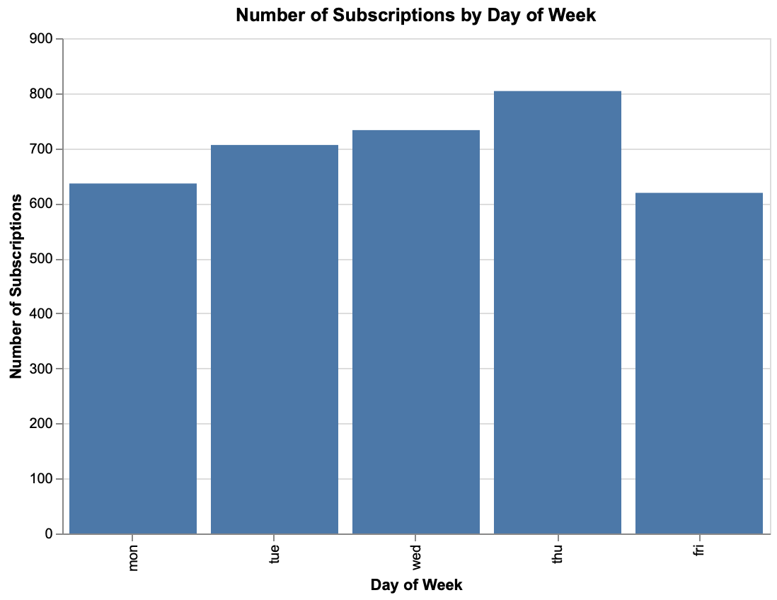
However, customer profile and prior relationship history remained far stronger predictors than timing alone.
Further, analysis of previous campaign outcomes (poutcome) demonstrated that customers who had previously responded positively (“success”) were dramatically more likely to subscribe again, over six times more likely than those who had never been contacted before. This finding reinforces the value of nurturing existing relationships and leveraging prior positive interactions as part of future campaign targeting.
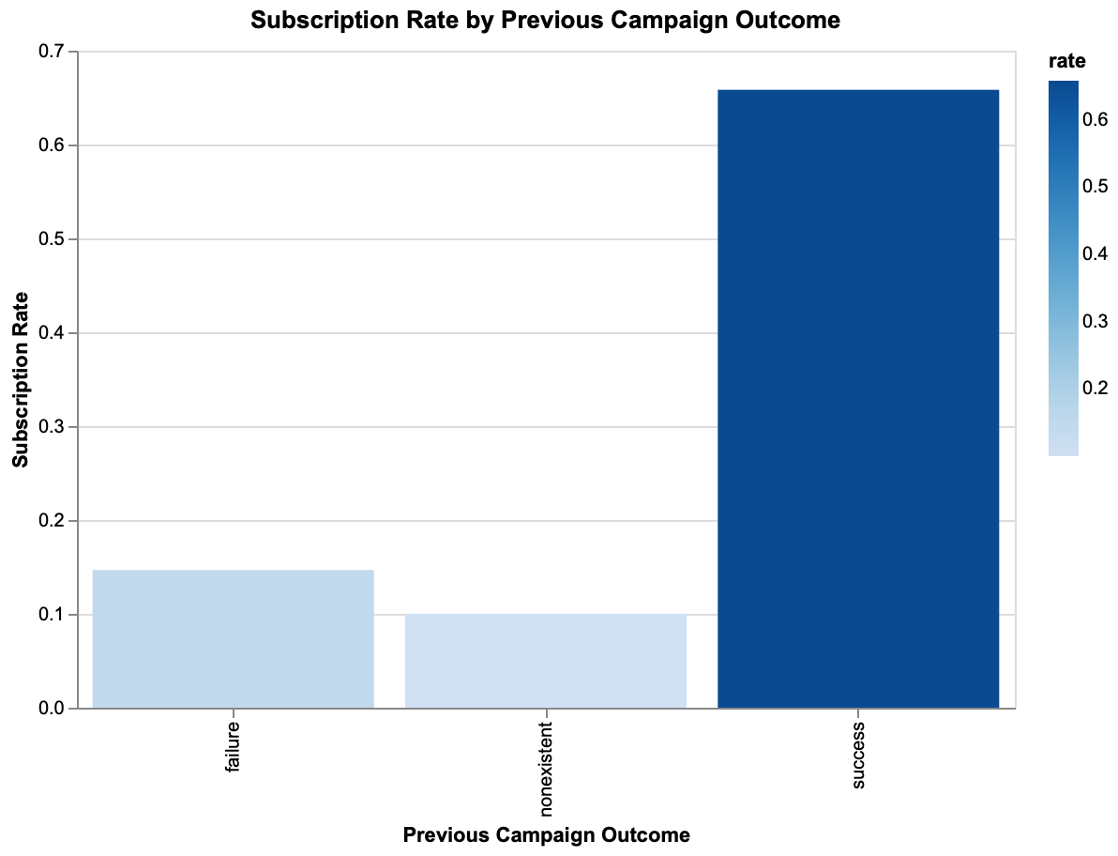
Based on these results, we recommend a targeted and data-driven outreach strategy. The bank should prioritize customers in administrative and technical roles and those with prior positive campaign responses.
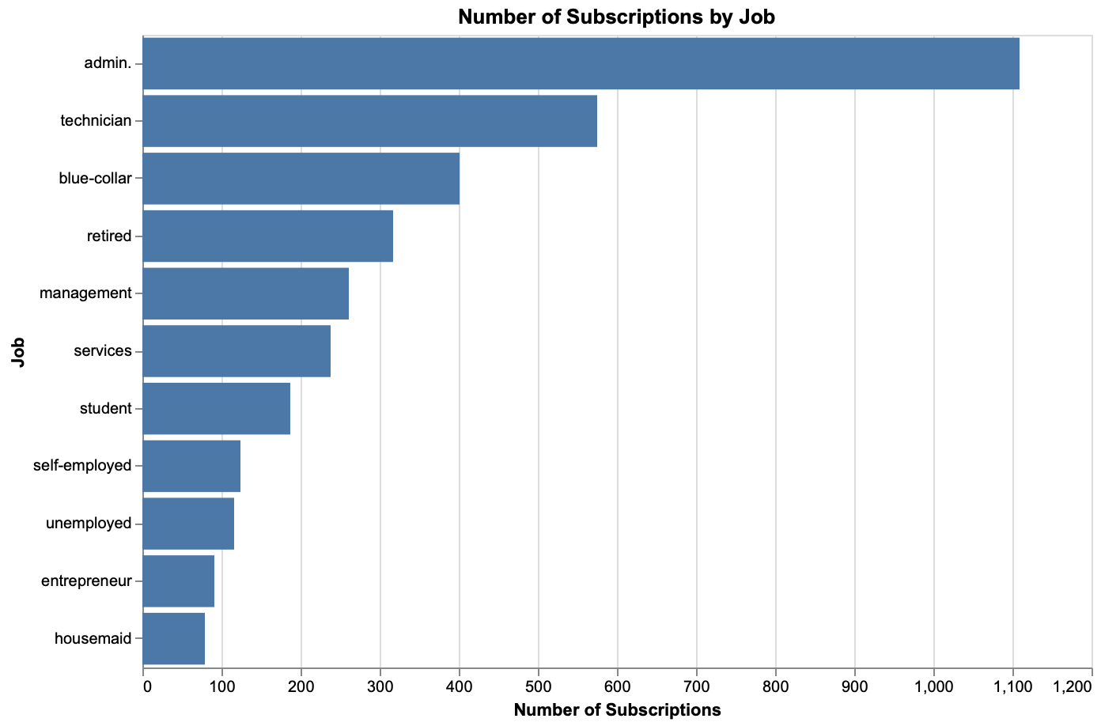

Campaigns should limit total contact frequency to prevent fatigue and preserve goodwill, while allocating resources toward re-engaging warm leads who have previously shown interest. Mid-week outreach should be favored for efficiency testing, but broader segmentation and personalized messaging will yield greater long-term gains. Finally, marketing intensity should align with economic conditions, scaling campaigns when interest rates are low and employment indicators are strong, and tightening focus when conditions are less favorable.
By implementing these recommendations, Banco Federal de Finanças can optimize marketing resources, improve conversion rates, and sustain compliance with privacy regulations while maintaining trust and transparency with its customers.
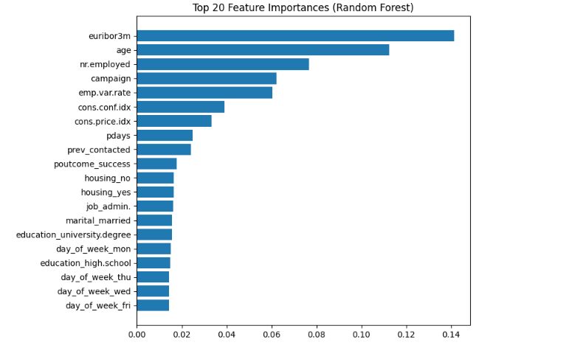

Methodology…
Our team developed a predictive model using a Random Forest Classifier to identify which customers are most likely to subscribe to a term deposit and to uncover the factors driving successful campaign outcomes. The model was trained on 27,477 cleaned campaign records after removing rows with missing or “unknown” values. To maintain class balance between subscribers and non-subscribers, an 80/20 stratified split was applied to create the training and test datasets.
Feature engineering included creating a binary variable, prev_contacted, to capture whether a customer had been previously contacted. This, along with economic indicators (euribor3m, nr.employed, emp.var.rate), demographic attributes (age, job, education), and campaign-related metrics (campaign, pdays, poutcome), formed the feature set used for modeling. The pipeline handled both categorical and numeric variables through one-hot encoding for categorical features and direct inclusion of numeric variables.
The Random Forest model was evaluated using accuracy, precision, recall, F1-score, and ROC-AUC metrics. It achieved an accuracy of 86.8%, an F1-score of 0.50, and a ROC-AUC of 0.80, demonstrating strong performance in distinguishing likely subscribers from non-subscribers.
- Python Notebooks
Below are Github Gist links to the notebooks we used during this case study:
- Data Cleaning and Exploration
- Data Modeling
- Holdout Set

- Discussion Responses
- Do you think a supervised or unsupervised approach would work best for this situation?
A supervised learning approach works best for this situation because the dataset includes a labeled outcome variable, whether a customer subscribed to a term deposit (y = yes or no). This allows the model to learn patterns between customer characteristics, campaign features, and known results, enabling accurate predictions for future campaigns.

- How much of that data will you use to train your model?

After cleaning the dataset and removing rows with missing or “unknown” values, we had 27,477 records available for modeling. We split this dataset using a stratified 80/20 split, with 80% (21,981 records) used for training and 20% (5,496 records) reserved for testing. This helped make sure the model is accurate and not memorizing the data it was trained on.

- I'm wondering if it's possible for us to see if those results are true for all customers, or if some types of customers respond better on certain days than others?

Our analysis showed that certain customer segments respond more positively to marketing efforts than others. Customers in administrative, technical, and retired roles had the highest subscription rates, indicating that job type and financial stability play an important role in predicting campaign success. Timing also had some influence, with slightly higher engagement during mid-week calls on Wednesday and Thursday, though this effect was much smaller compared to customer profile and prior contact history. These findings suggest that while day-of-week scheduling can provide a minor lift, focusing outreach on high-yield segments and re-engaging customers with previous positive responses will have a much greater impact on overall campaign performance.

- What do you think we might need to do for this project in order to be compliant with GDPR regulations?

Although the dataset does not include direct personal identifiers, it still contains personal data that could fall under GDPR. The bank would need to verify consent and maintain transparency with customers about how their data is being used.

